Sweet potato puree
in three ways
___________________________________________________________________________

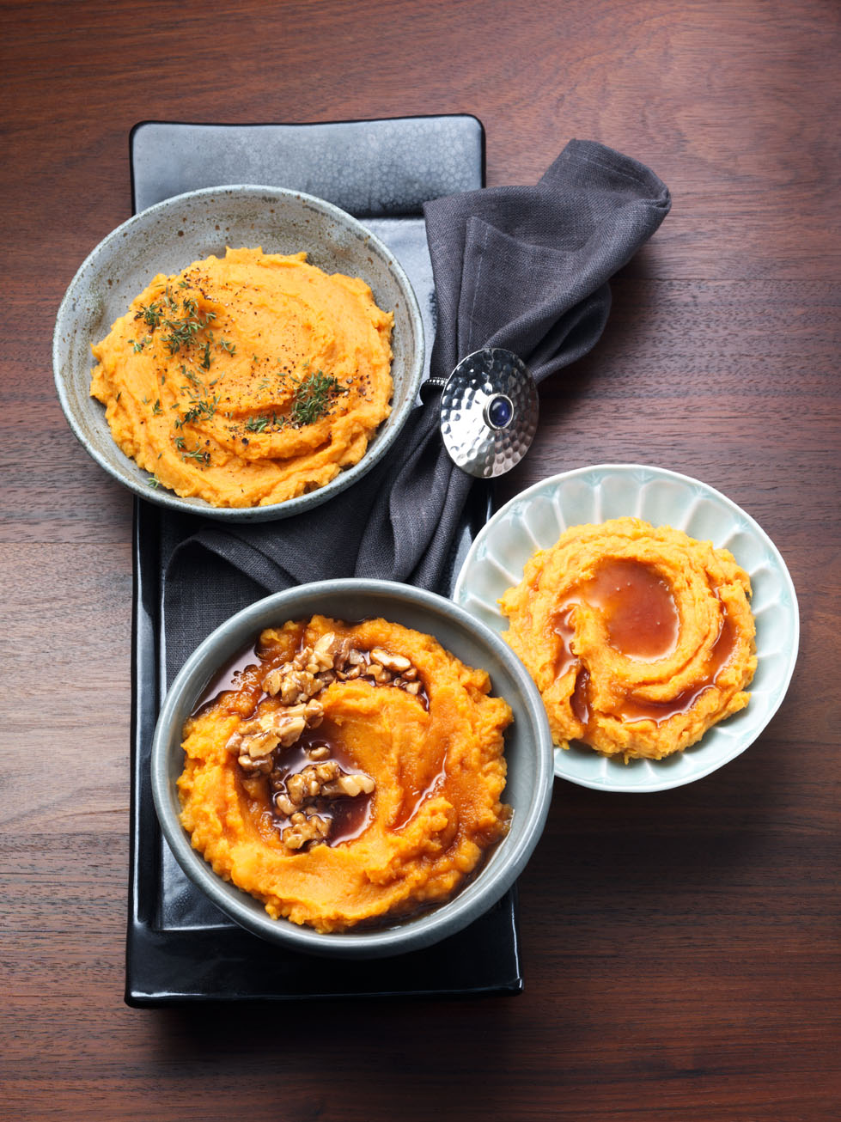
Sweet potato puree with honey

Ingredients for 4 servings:
1 kg sweet potatoes from North Carolina
Salt
50 ml vegetable broth (instant)
75 ml milk
25 g butter
6 tbsp honey

- Wash and peel sweet potatoes and chop them coarsely.
Boil them in salted water for 15-20 minutes until soft. Meanwhile heat the vegetable stock with the milk and the butter.

- Drain sweet potatoes and mash them with a potato masher. Add the milk mixture. Season with pepper. Add the honey loosely to the puree.

Preparation time ca. 35 minutes.

Nutrition facts per portion:
Energy: 383 kcal / 1600 kJ
protein: 4,84 g
fat: 7,37 g
carbohydrates: 72,4 g

Sweet potato puree with thyme

Ingredients for 4 servings:
1 kg sweet potatoes from North Carolina
Salt
1 bunch of thyme
1 tsp olive oil
50 ml vegetable broth (instant)
75 ml milk
25 g butter
Pepper
Freshly grated nutmeg

- Wash and peel sweet potatoes and chop them coarsely. Boil them in salted water for 15-20 minutes until soft.

- In the meantime, wash the thyme, shake dry and pluck the leaves from the stems. Heat olive oil in a small pan and roast half of the thyme in it. Heat the vegetable stock, the milk and the butter.

- Drain the sweet potatoes and mash them with a potato masher. Add the milk mixture and season with salt, pepper and nutmeg. Add fried and fresh thyme to the puree.

Preparation time: approx. 35 minutes

Nutritional values per person:
Energy: 349 kcal / 1460 kJ
protein: 4,8 g
Fat: 8,63 g
carbohydrates: 61,2 g

Sweet potato and carrot puree with walnuts

Ingredients for 4 people:
700 g sweet potatoes from North Carolina
300 g carrots
Salt
60 g walnuts
150 ml sherry vinegar
9 tbsp honey
50 ml vegetable broth (instant)
75 ml milk
25 g butter

- Peel carrots and sweet potatoes, wash and chop them coarsely. Boil them in salted water for 15-20 minutes until soft.

- Meanwhile chop walnuts coarsely and roast them in a pan without fat. Cook 6 tablespoons of honey and vinegar for 5-10 minutes until thick. Add walnuts and set aside.
3. Heat vegetable stock, milk and butter. Drain carrots and potatoes. Mash finely with a potato masher, adding the milk mixture. Pour the sweet and sour walnuts over the mashed potatoes and carrots.

Preparation time: ca. 35 Minuten.
Nutrition facts per portion:
Energy: 447 kcal / 1870 kJ
Fat: 16,4 g
Carbohydrates: 65,4 Protein: 6,69 g

