Spicy sweet potato salad with spinach

Ingredients (2 servings):

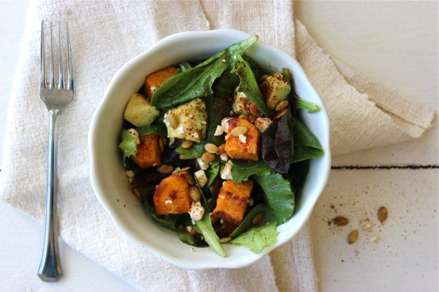
1 large sweet potato from North Carolina (300 g)
4 tbsp olive oil
1/2 teaspoon salt
1 teaspoon chili powder
2 tbsp lime juice
1 tsp honey
1/4 tsp black pepper
250 g spinach
50 g feta cheese
30 g soybeans

- Peel and chop sweet potatoes. Then spread on a baking sheet and spread with 1 tablespoon of oil and sprinkle with ¼ teaspoon salt. Bake for approx. 30 minutes in a preheated oven (electric cooker: 200°C/ gas cooker: level 3) until golden brown, turn occasionally.

- take sweet potato cubes out of the oven and season with chilli powder, allow to cool.

- Mix the remaining oil, lime juice, honey, salt and pepper in a small bowl.

- Dice feta cheese and avocado. Put the salad leaves in a bowl, add the cheese, soya beans, avocado and the baked sweet potato cubes. Pour the dressing over the salad and serve.

Nutrition facts per serving:

Energy160 kcal/670 kJ
Protein17 g
Fat43g
Carbohydrates16 g

