Classic sweet potato salad

Ingredients (4-6 servings):

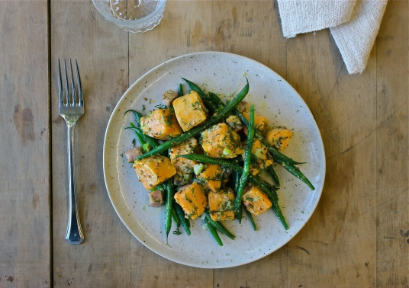
1 kg sweet potatoes from North Carolina
500 g green beans
1/3 cup olive oil
180 g lean cooked ham
3 small shallots
2 tablespoons fresh lemon juice
2 tbsp grainy mustard
1 tablespoon mayonnaise
2 tsp fresh dill
Salt, pepper

Directions:

- Peel and chop sweet potatoes. Then cook in salted water for about 6 minutes.

2. Add the green beans and cook for 3-4 minutes. The beans should remain crisp. Drain the water.

3. Heat 2 tablespoons of oil in a deep pan at medium heat. Cut the ham into cubes and fry in the pan for 3-5 minutes until golden brown. Remove from heat and allow to cool for 2 minutes.

4. Finely chop the shallots and add to the ham with the remaining oil, lemon juice, mustard, mayonnaise, salt, pepper and 2 tbsp. water and mix.

5. Add sweet potatoes, beans and chopped dill, mix in and serve.

