Ceviche with sweet potatoes

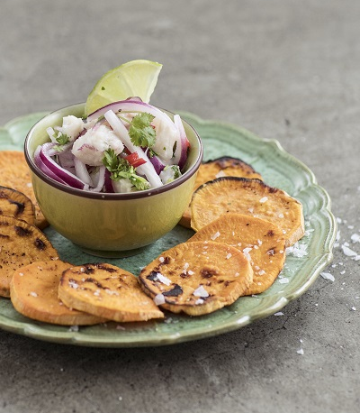
Ingredients for 4 servings:
4 sweet potatoes from North Carolina
500 g white fish (for example cod)
3 red onions
Juice of 6 limes
Possibly rhubarb juice
2 red bell peppers
Cilantro
500 ml fish stock (stock cubes or homemade stock made from carcasses, onions and garlic)
salt and pepper
sea salt
1 pinch of chilli if necessary

Directions:

- Peel sweet potatoes and cut them into slices. Peel and halve the onions and cut them into even fine slices. Add 500 ml water and 2 teaspoons salt to a bowl and leave to stand for 15 minutes. Then place the onions in a sieve and wash twice thoroughly with water. This will provide a milder taste.

- Wash the bell peppers and cut them into 2 mm cubes. Cut the fish into 1 cm cubes and keep cool. Wash the coriander.

- Put the fish stock, lime juice, coriander and paprika in a bowl. Season with salt and chilli (if desired) and put in the fridge for 20 minutes.

- Remove the coriander and add the fish to the remaining ingredients. Season with salt, pepper and more lime juice.

- Roast the sweet potato slices in a toaster or in a pan. Sprinkle with sea salt. Serve the ceviche in a bowl together with the sweet potato toasties. Sprinkle with lime juice and coriander leaves.

